ServiceNow Micro Project Report
Import Data Using Transform Maps – Spreadsheet-Based Employee Data Import, Validation and Analytics
Team ID: MKU201Team56ab4dc836f290be8a6b49be8 Date: 30 September 2026

1. Introduction

1.1 Project Overview
This micro project shows how structured employee data stored in an Excel spreadsheet can be imported into ServiceNow using Import Sets and Transform Maps. The spreadsheet is loaded into a staging Import Set table (u_employee_import), and a Transform Map transfers the source fields to a custom target table, Employee Test (u_employee_test). Records are validated, duplicates are handled with Coalesce, and reports and a dashboard present the employee information.

1.2 Purpose
- Create a custom Employee Test table with the required employee fields.
- Load spreadsheet data into an Import Set staging table.
- Configure a Transform Map and map source fields to target fields.
- Run the transformation and verify imported records.
- Use Coalesce on Employee ID to update existing records and avoid duplicates.
- Create department, location and employee-list reports and combine them in a dashboard.

2. Ideation Phase

2.1 Problem Statement
PS | I am | I'm trying to | But | Because | Which makes me feel
PS-1 | an HR / ServiceNow administrator | load employee data from a spreadsheet into ServiceNow | manual entry is slow and re-uploads create duplicates | there is no automated field mapping or Coalesce matching | frustrated and worried about accuracy
PS-2 | a manager | see employees by department and location | data is scattered in spreadsheets | there are no reports or dashboard | uninformed

2.2 Empathy Map Canvas
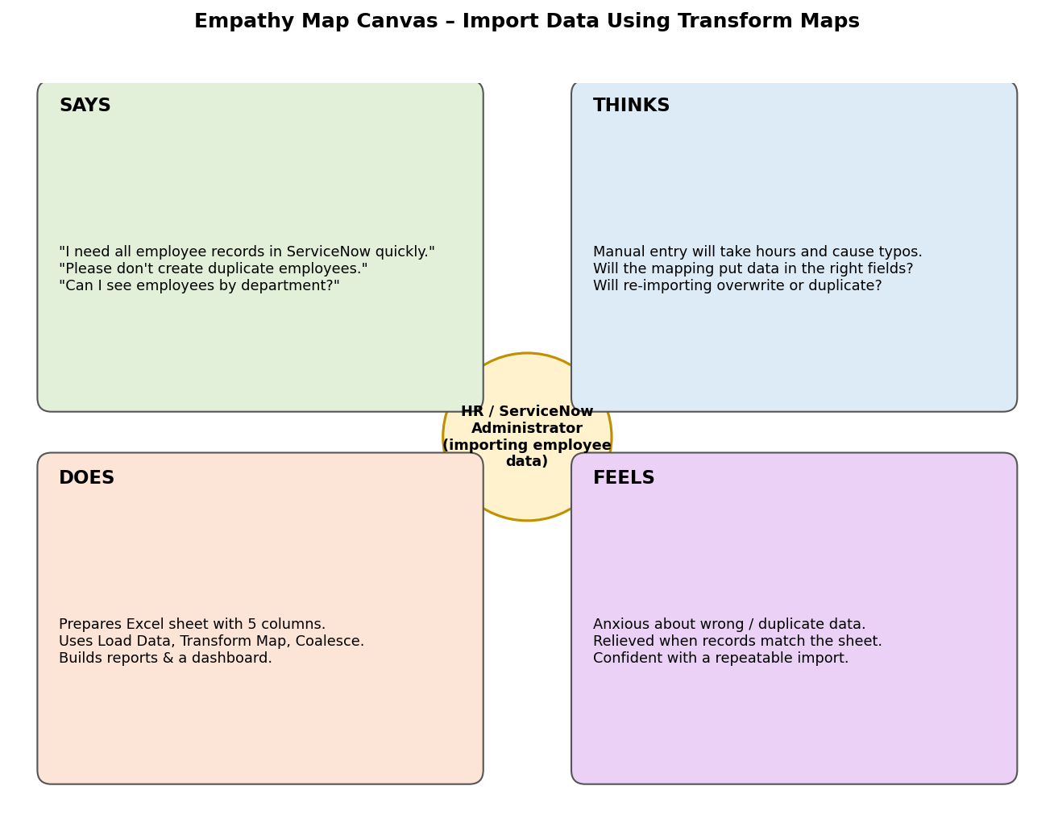
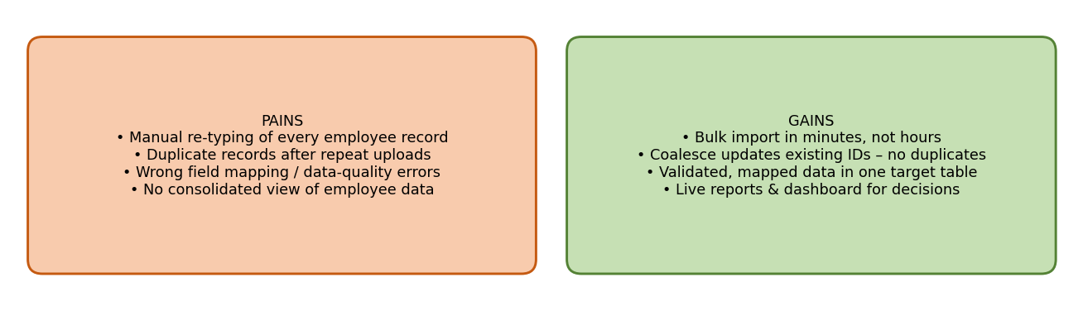

2.3 Brainstorming
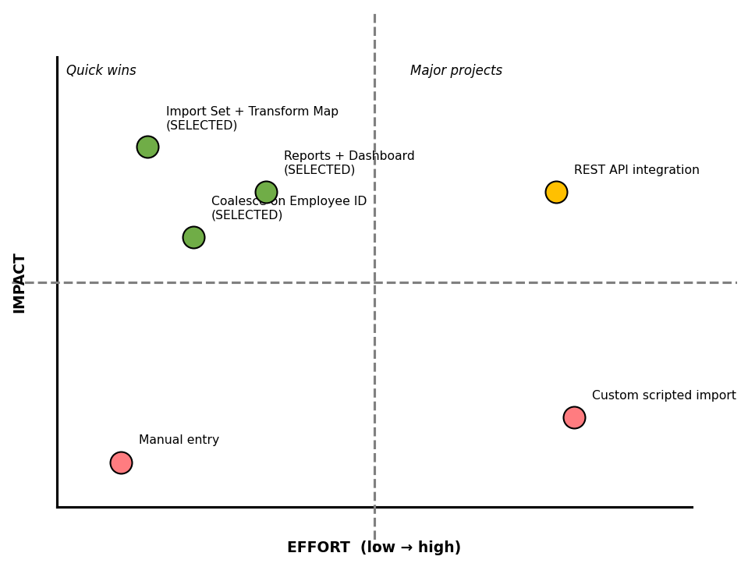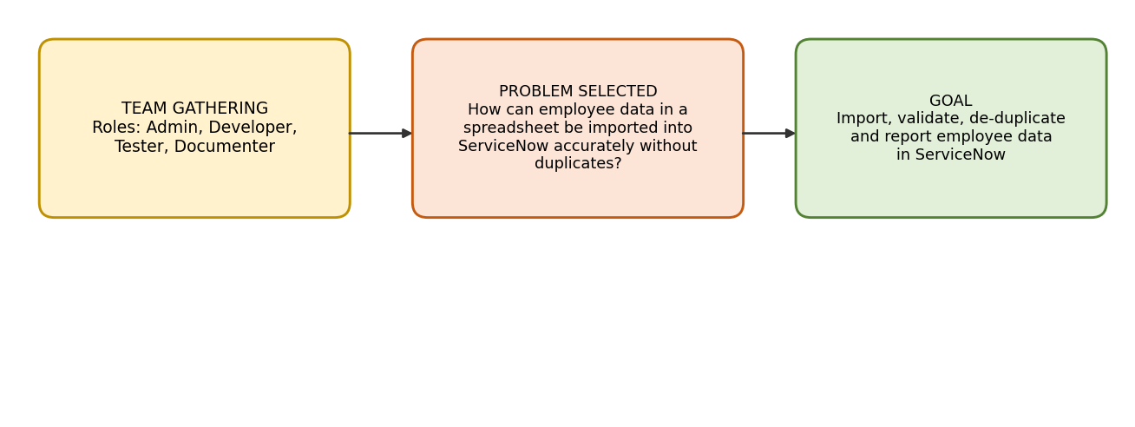
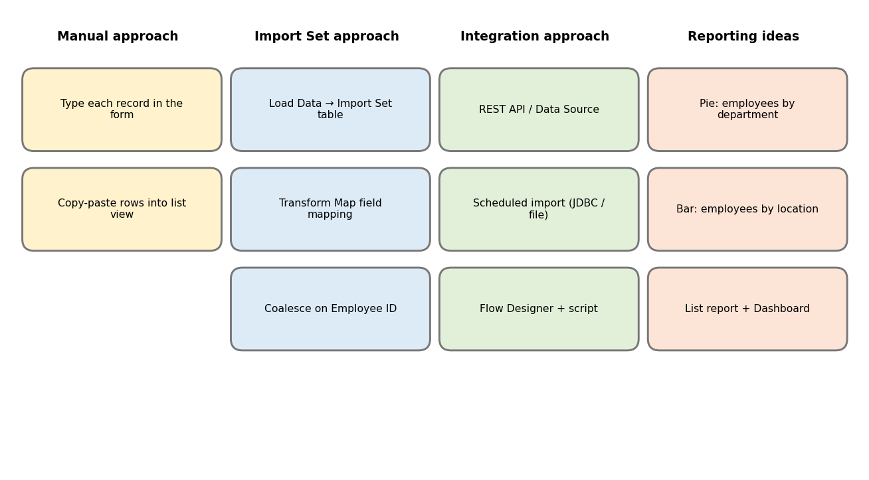
3. Requirement Analysis

3.1 Customer Journey Map
2. Requirement Analysis/Customer Journey Map.docx'.
Stages:
Need → Prepare → Import → Validate → Update / De-duplicate → Report & Review.

3.2 Solution Requirements
FR No. | Functional Requirement | Sub Requirement
FR-1 | Spreadsheet Preparation | Header row, five columns, save as .xlsx
FR-2 | Custom Target Table | Employee Test (u_employee_test) with five String fields
FR-3 | Import Set Staging Table | Load Data → Employee Import (u_employee_import)
FR-4 | Transform Map | Sample Spreadsheet Import with five field maps
FR-5 | Transformation & Validation | Run Transform, compare with spreadsheet
FR-6 | Duplicate Prevention | Coalesce = true on Employee ID
FR-7 | Reporting | Pie, Bar and List reports
FR-8 | Dashboard | Employee Analytics Dashboards with three widgets

NFR No. | Non-Functional Requirement | Description
NFR-1 | Usability | Low-code guided navigation and simple five-column template
NFR-2 | Security | Role-based access; only authorized admins change ACLs
NFR-3 | Reliability | Coalesce keeps data consistent across imports
NFR-4 | Performance | Bulk import through staging table; fast aggregate reports
NFR-5 | Availability | ServiceNow cloud instance
NFR-6 | Scalability | Transform map reusable for larger files and more fields

3.3 Data Flow Diagram
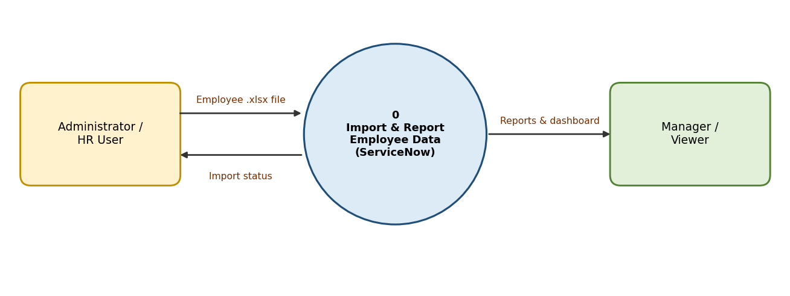
DFD Level 0
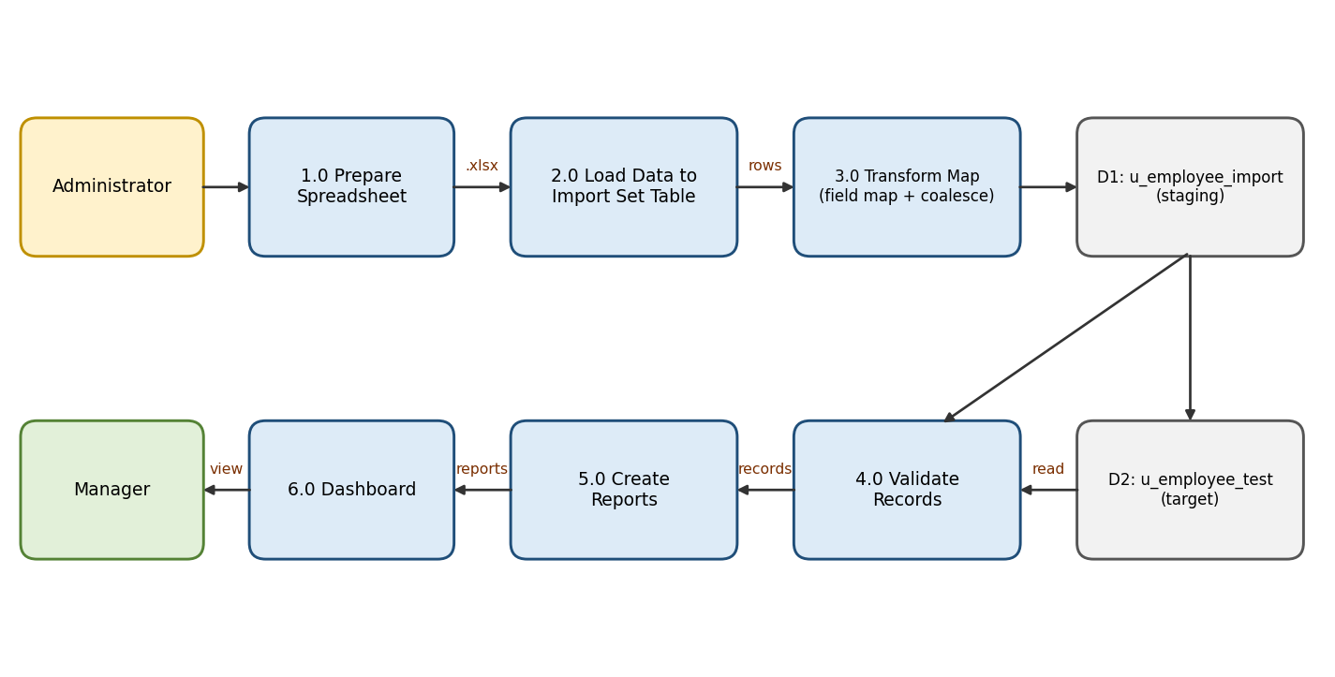
DFD Level 1

3.4 Technology Stack
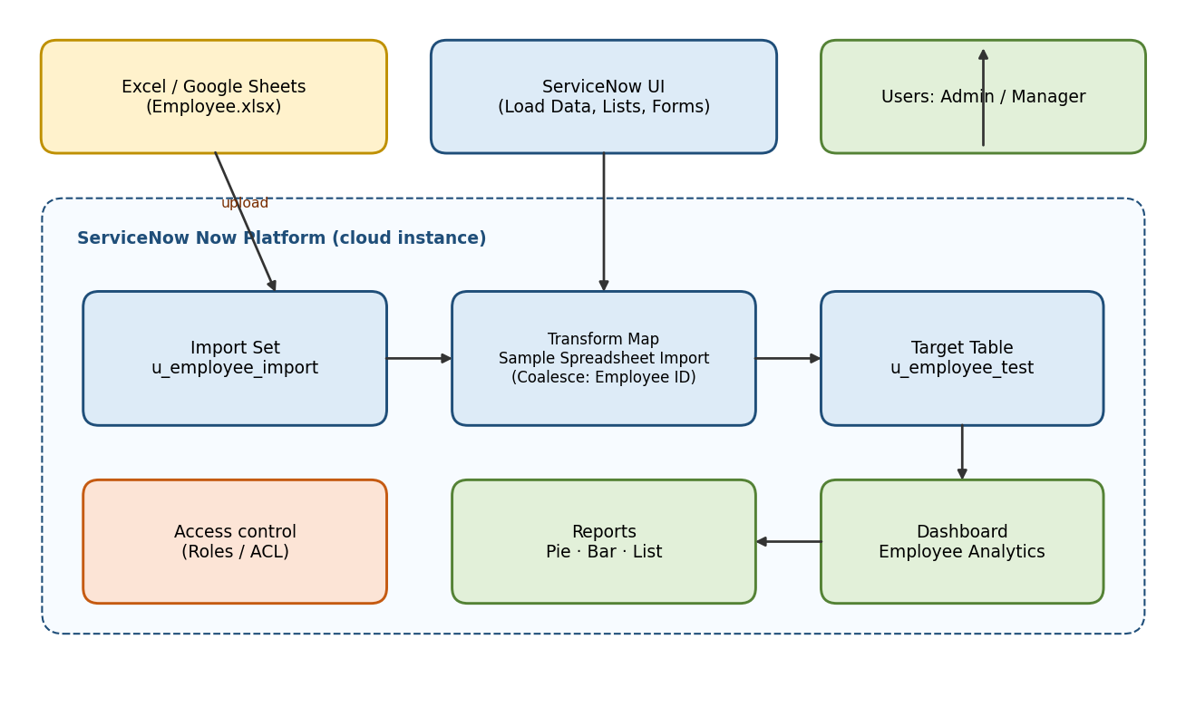
Component | Description | Technology
User Interface | Application Navigator, Load Data, forms, lists, dashboards | ServiceNow Now Platform UI
Application Logic-1 | Import Set staging | Import Sets
Application Logic-2 | Field mapping and Coalesce | Transform Maps
Application Logic-3 | Reports and dashboard | ServiceNow Reporting
Database | u_employee_import, u_employee_test | ServiceNow tables
File Storage | Source .xlsx file | Excel / Google Sheets
Infrastructure | Cloud-hosted instance | ServiceNow Cloud

4. Project Design

4.1 Problem Solution Fit
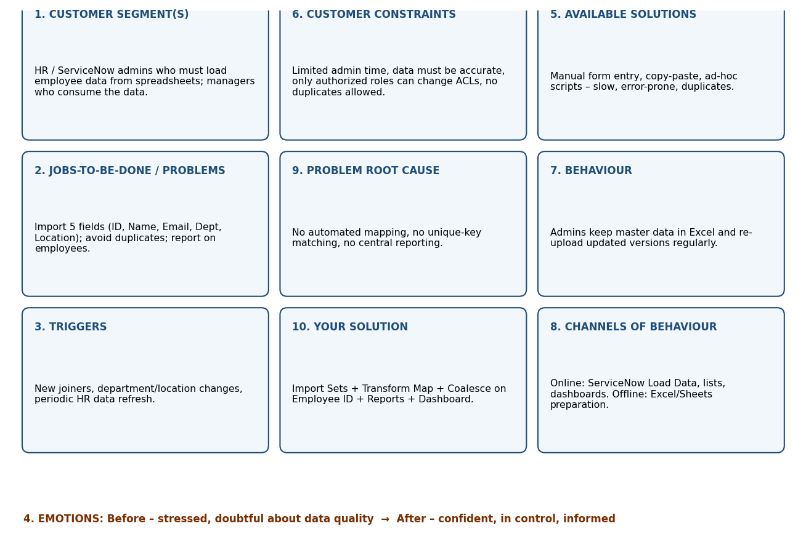

4.2 Proposed Solution
S.No. | Parameter | Description
1 | Problem Statement | Manual, error-prone spreadsheet-to-ServiceNow data entry with duplicates and no consolidated view
2 | Solution | Import Set + Transform Map + Coalesce + reports + dashboard
3 | Novelty | Repeatable low-code end-to-end import and analytics workflow
4 | Social Impact | Saves time, reduces errors, improves trust in HR data
5 | Business Model | Internal productivity solution / reusable data-migration accelerator
6 | Scalability | Reusable for more rows, fields and tables

4.3 Solution Architecture
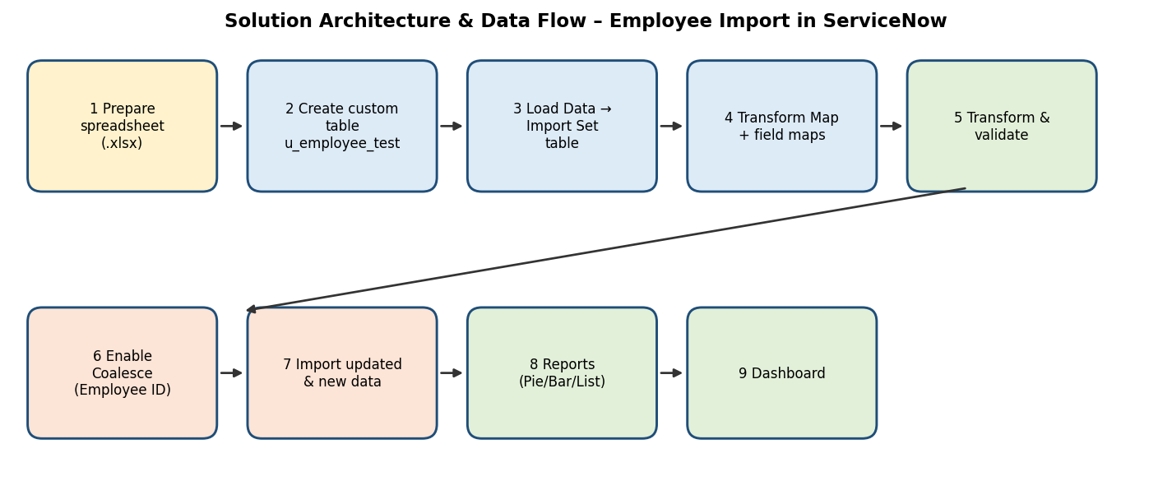

5. Project Planning & Scheduling

5.1 Project Planning
Three sprints of 3 days with 10 story points each (30 total). Velocity = 30 / 3 = 10 story points per sprint (≈3.33 per day).
Sprint | Epic | Stories | Points | Dates
Sprint-1 | Data Preparation, Table Creation, Import Set | USN-1 to USN-4 | 10 | 21–23 Sep 2026
Sprint-2 | Transform Map, Duplicate Handling | USN-5 to USN-8 | 10 | 24–26 Sep 2026
Sprint-3 | Re-import, Reports, Dashboard | USN-9 to USN-12 | 10 | 27–29 Sep 2026
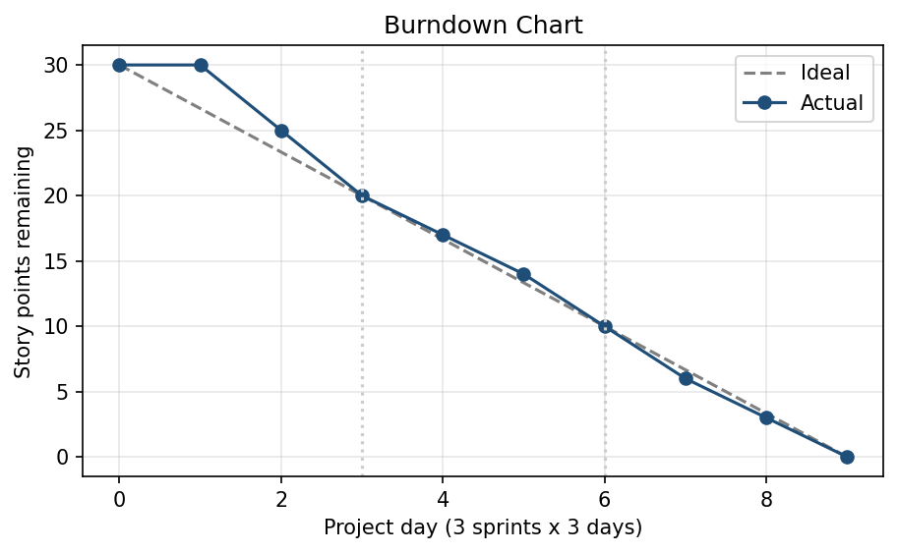

6. Functional and Performance Testing

6.1 Performance Testing
- Field mapping: 5 of 5 fields mapped.
- Import validation: imported rows compared with the source spreadsheet and matched.
- Coalesce test: 2 existing IDs updated, 2 new IDs inserted; re-import of the unchanged file created no additional records.
- Reports and dashboard: 3 reports and 1 dashboard with 3 widgets.
Detailed test cases are in '5. Project Development Phase/User Acceptance Testing/UAT Report - ServiceNow.docx'.

7. Results

7.1 Output Screenshots
- Sample spreadsheet
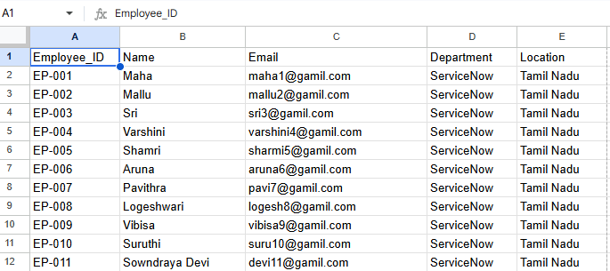

- Custom table creation (Employee Test)
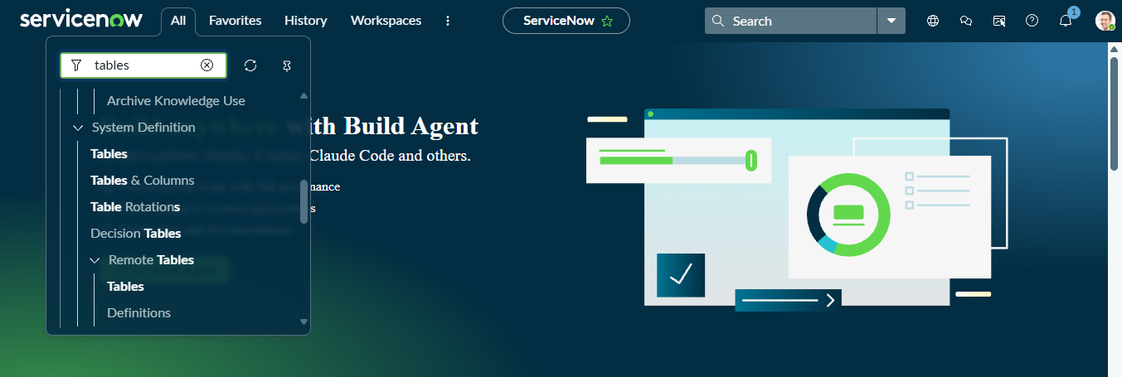
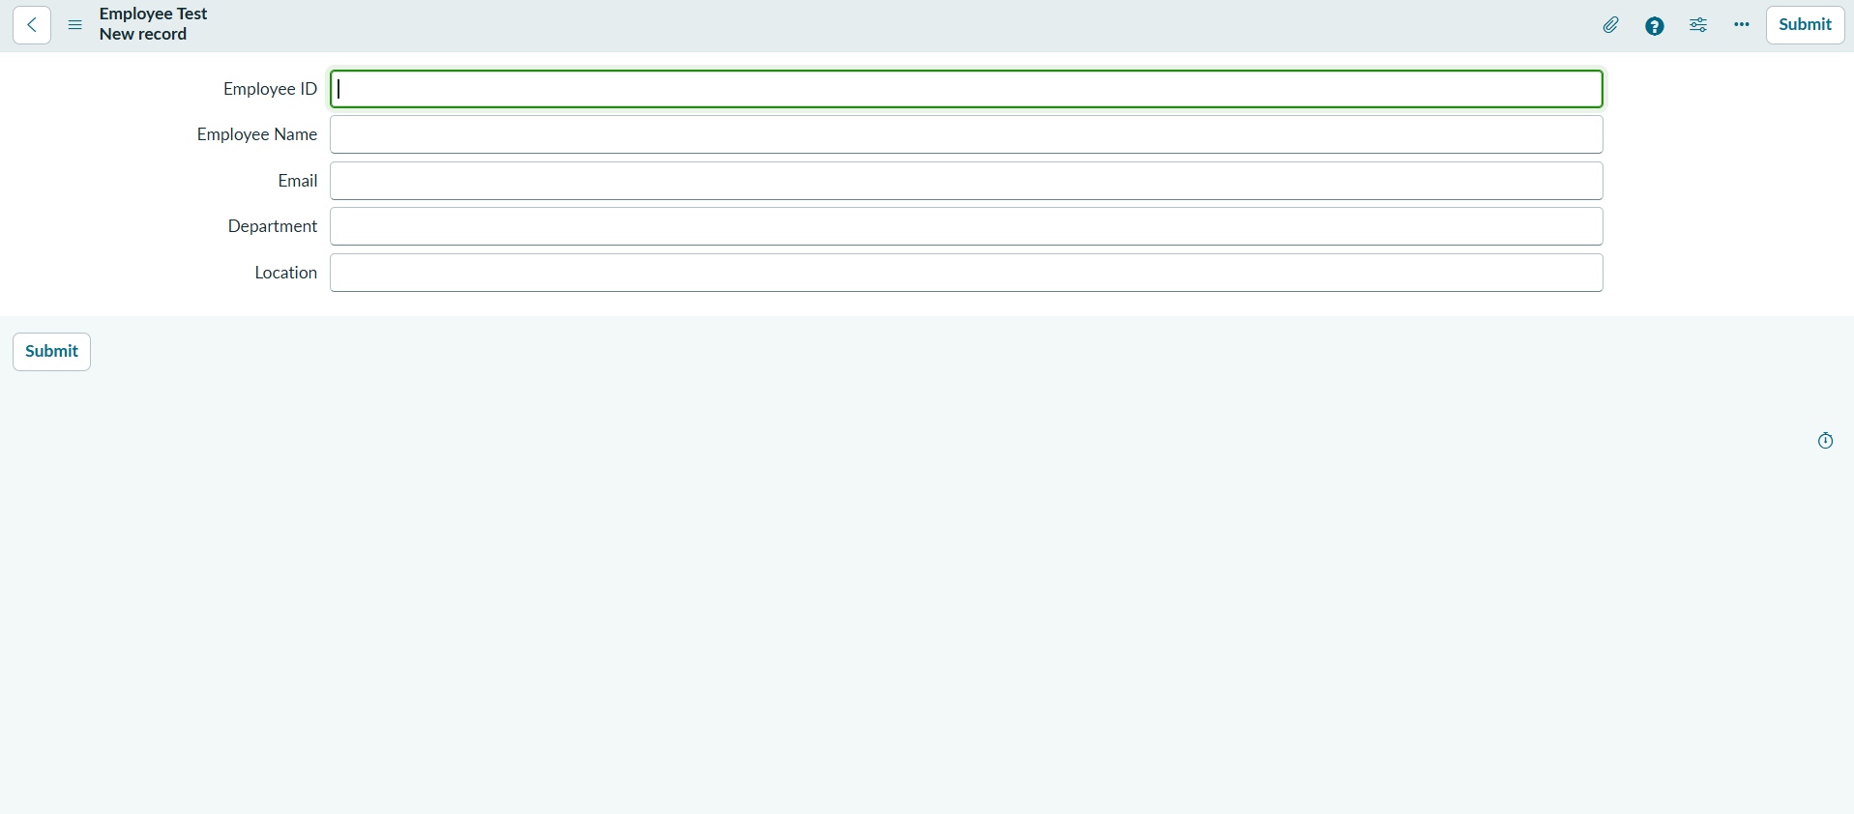
- Import set table (Employee Import)
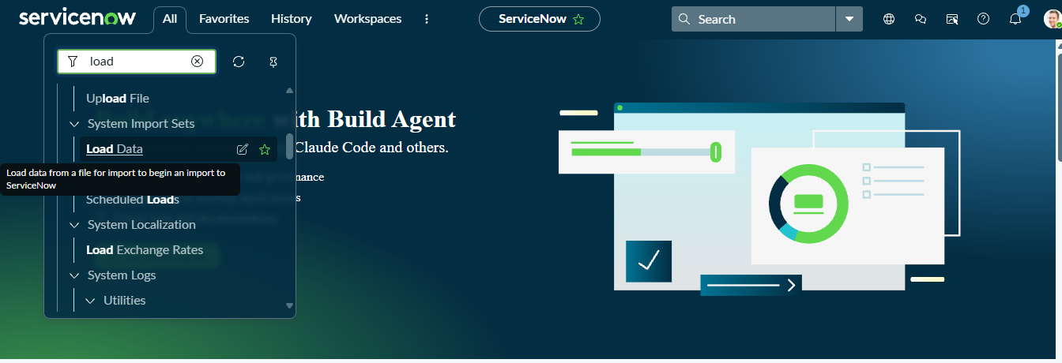
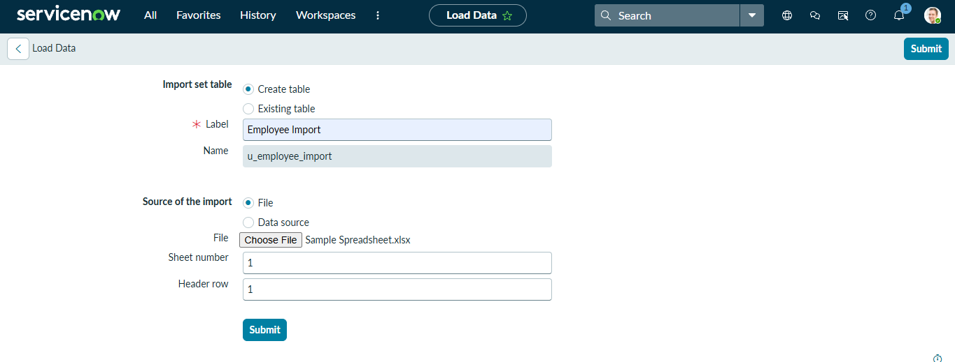

- Transform Map field mappings
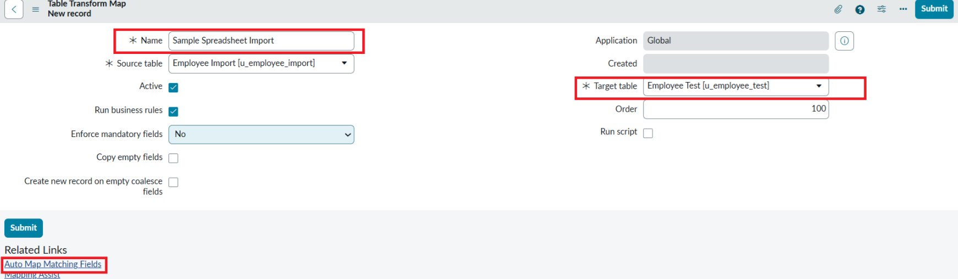
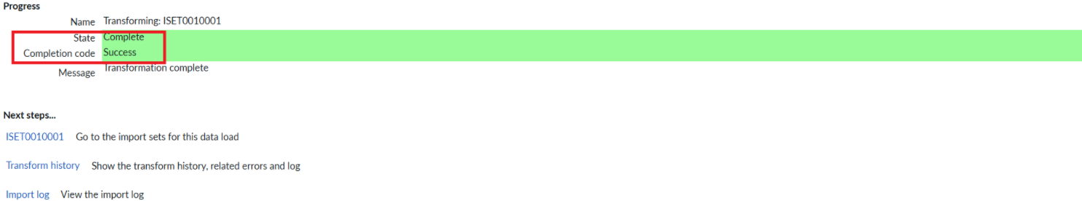

- Employee Test list after transformation
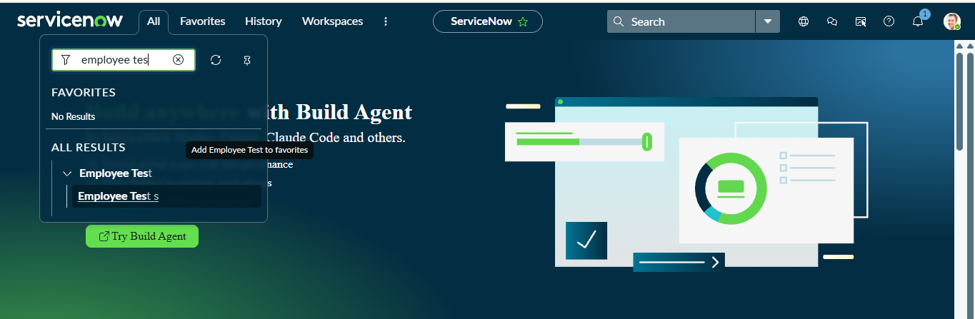
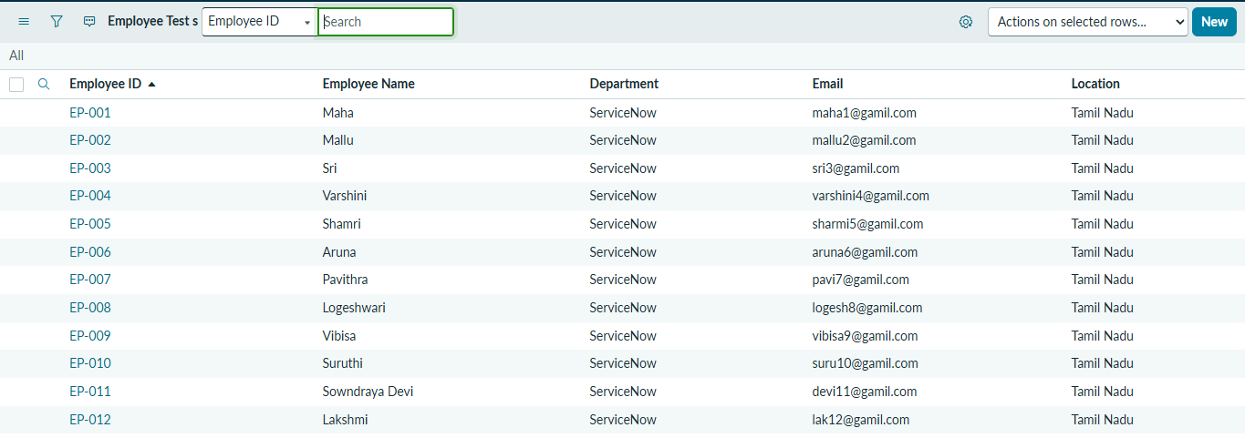

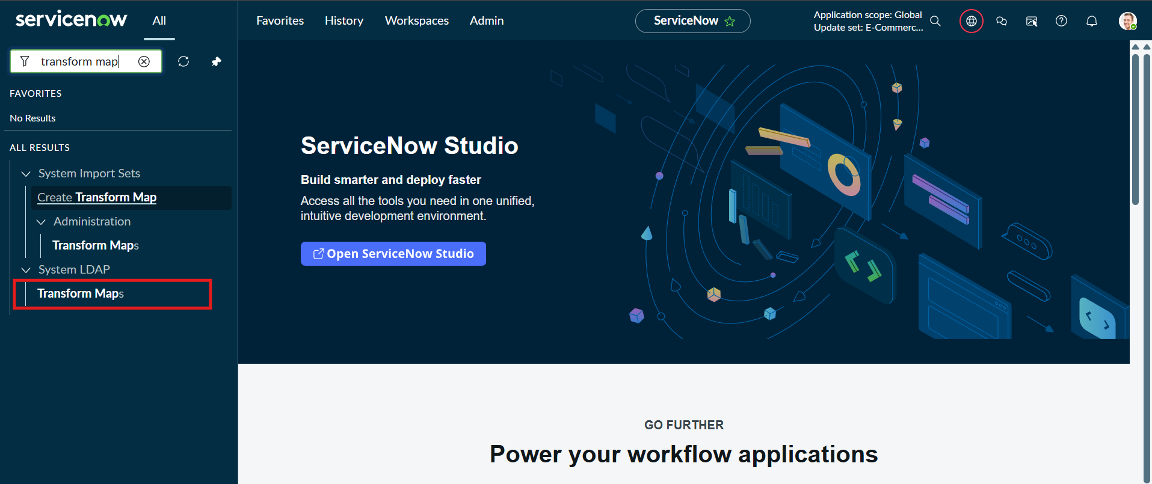
- Coalesce field map (Employee ID = true)

- Reports: Employees by Department, Employees by Location, Employee List Report

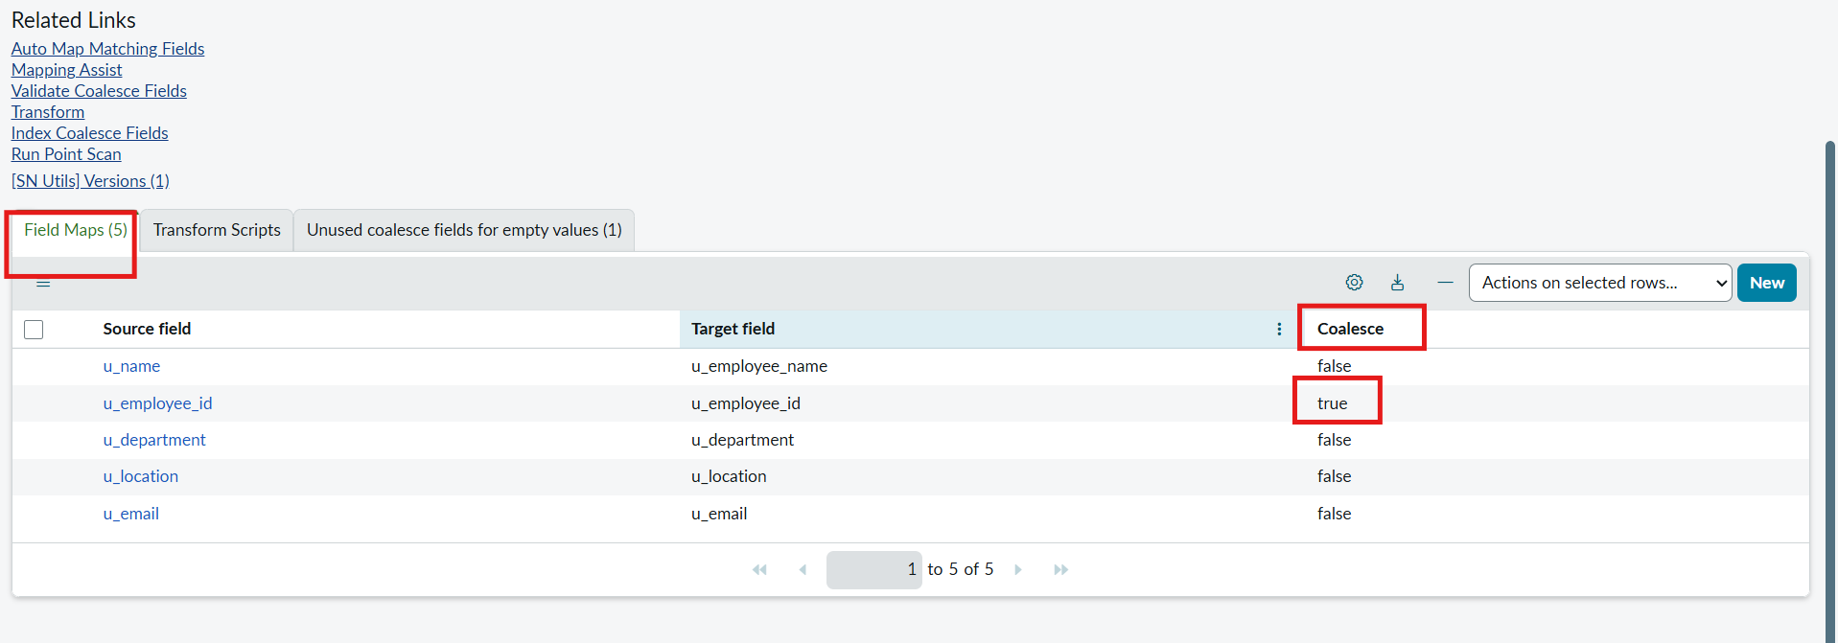
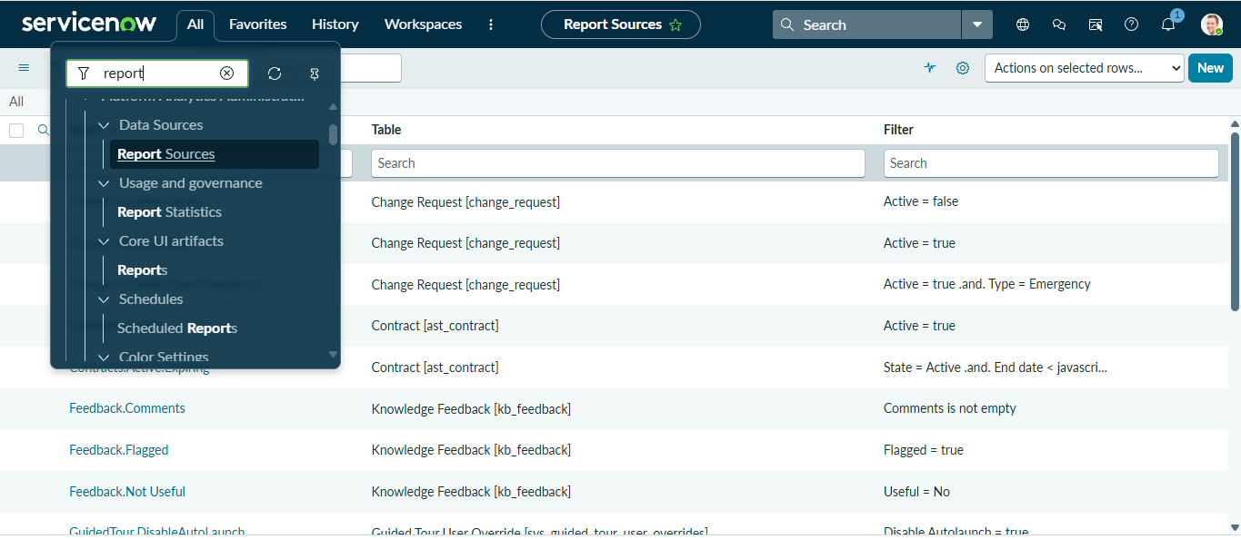
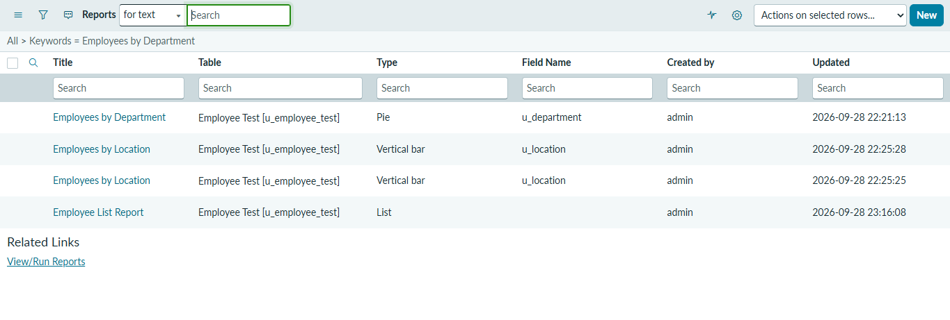
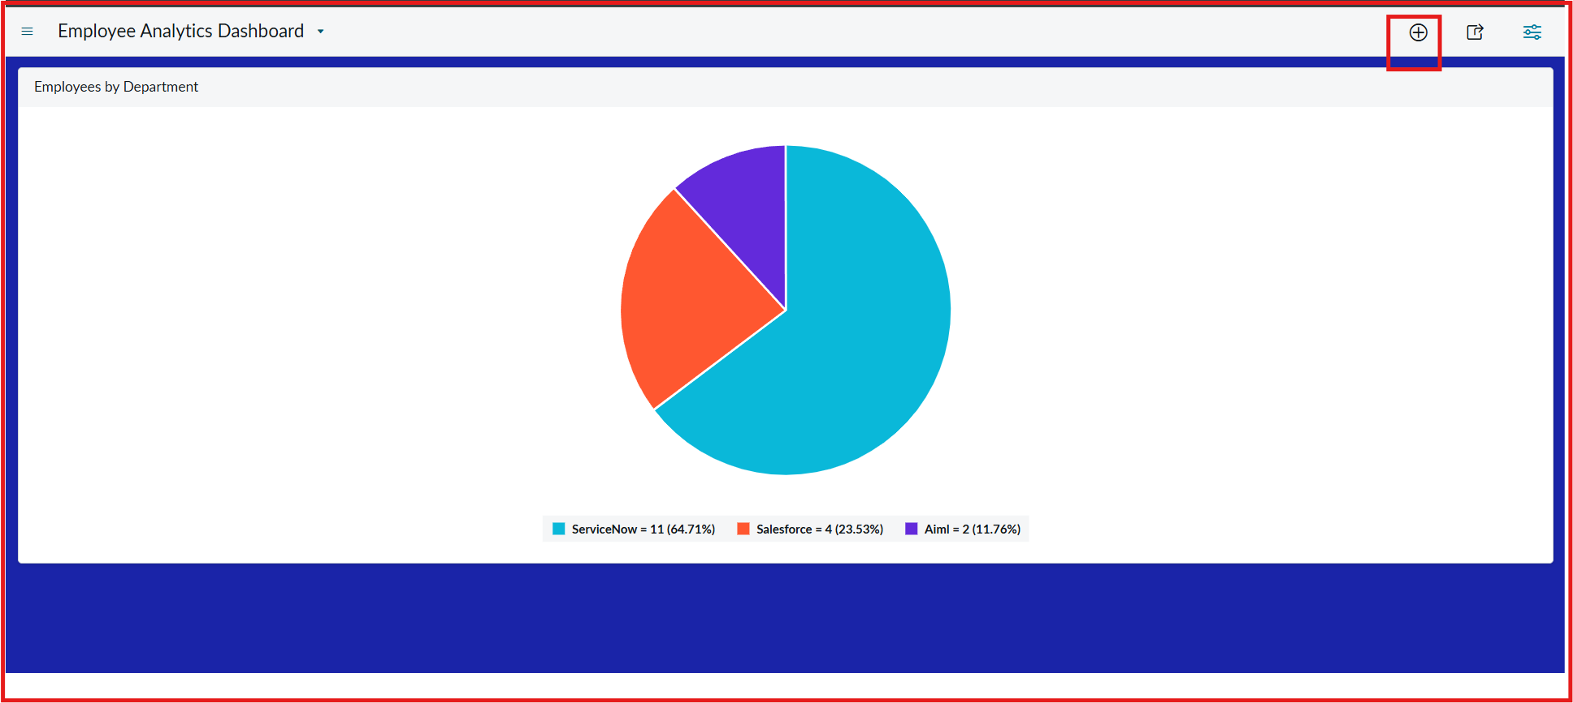
- Employee Analytics Dashboards
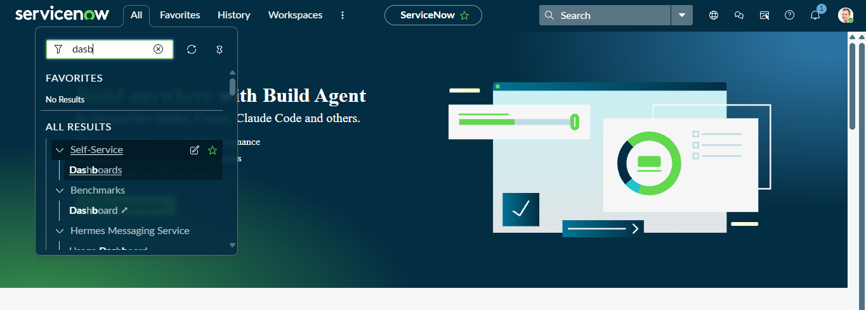

8. Advantages & Disadvantages
Advantages
- Fast bulk import with no custom code.
- Coalesce prevents duplicate employees.
- Repeatable process for updated files.
- Instant reporting and dashboard for managers.
Disadvantages
- Depends on a clean, consistent spreadsheet layout.
- Manual upload step unless scheduling is added.
- Dashboard creation may need administrator ACL changes.
- Status labels vary by ServiceNow version.

9. Conclusion
The project gives practical experience in spreadsheet data migration, staging tables, field mapping, transformation, duplicate prevention and reporting in ServiceNow. Import Sets, Transform Maps, Coalesce, reports and a dashboard together form a repeatable workflow for importing and reviewing employee data.

10. Future Scope
- Schedule imports with a data source instead of manual upload.
- Add validation rules and transform scripts for email and department values.
- Extend the map to more fields, e.g. manager, phone, joining date.
- Add role-based dashboards and notifications for failed imports.

11. Appendix
- Source code: none (no-code / low-code configuration)
- Dataset link: Sample employee spreadsheet (Google Sheets)
- Project demo link: Watch project demo video

